Objective Questions:

1. What is the distribution of account balances across different regions?

The distribution of account balances across regions exhibits a marked concentration in France and Germany. France accounts for the largest proportion of total balances, comprising 40.70%, while Germany closely follows with 39.28%. In contrast, Spain represents a substantially smaller share, contributing 20.02% of the overall account balances.
This distribution indicates that nearly four-fifths of total account balances are concentrated within France and Germany, suggesting a higher level of financial activity or customer engagement in these regions. The comparatively lower share observed in Spain may reflect differences in market penetration, customer base size, or regional economic factors.

2. Identify the top 5 customers with the highest Estimated Salary in the last quarter of the year.

QUERY:
SELECT
CustomerId,
STR_TO_DATE(`Bank_DOJ`, '%d-%m-%Y') AS Bank_DOJ,
Surname,
EstimatedSalary
FROM customerinfo
WHERE QUARTER(STR_TO_DATE(`Bank_DOJ`, '%d-%m-%Y')) = 4
ORDER BY EstimatedSalary DESC
LIMIT 5;

OUTPUT:
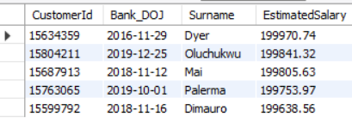

In the last quarter of the year (October–December), all five customers in the dataset qualify. Dyer has the highest estimated salary at 199,970.74. Oluchukwu comes next with 199,841.32, followed by Mai at 199,805.63. Palermo holds 199,753.97, and Dimauro has 199,638.56. This shows that Dyer is the top earner, while Oluchukwu, Mai, Palermo, and Dimauro complete the group of the top five customers in the last quarter

3. Calculate the average number of products used by customers who have a credit card.

Query:
select avg(numofproducts) as avg_product
from bank_churn b
where HasCrCard=1;

output:
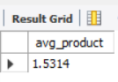
We can see that, the average number of products used by the customers who have a credit card is 1.5314.

4. Determine the churn rate by gender for the most recent year in the dataset.
Churn rate is the number of customers who have made an exit to the total number of customers, computed using a calculated measure in power BI.

Formula:
lost_cust = CALCULATE( DISTINCTCOUNT(CustomerInfo[CustomerId]), Bank_Churn[Exited] = 1,YEAR( CustomerInfo[Bank DOJ])=2019 )
Tot_cust=CALCULATE(DISTINCTCOUNT(CustomerInfo[CustomerId]), YEAR( CustomerInfo[Bank DOJ])=2019 )
churn_Rate = ROUND( DIVIDE( [lost_cust],[Tot_cust] )*100 ,3)
Above churn rate gives rate of exited customers in the last year 2019.
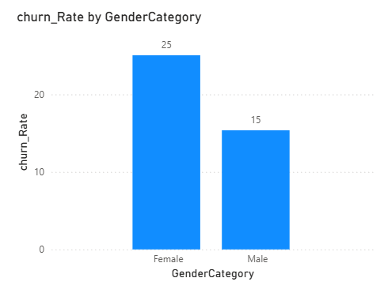

- Churn rate for Males in 2019 is 15.
- Churn rate for Females in 2019 is 25.

5. Compare the average credit score of customers who have exited and those who remain.

Query:
select e.Exitcategory,avg(bc.CreditScore) as avg_credict_score
from bank_churn bc
join exitcustomer e on bc.Exited=e.Exitid
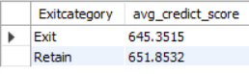
group by e.Exitcategory

Output:

The table shows that customers who retained their accounts have a higher average credit score (651.85) compared to customers who exited (645.35). This indicates that customers with stronger credit profiles are slightly more likely to stay, while those with lower credit scores have a higher tendency to chur

6. Which gender has a higher average estimated salary, and how does it relate to the number of active accounts?

Query:
select GenderCategory,round(avg(EstimatedSalary),2) as Avg_estimated_sal,
count(bc.CustomerId) as Active_Customers
from customerinfo ci
join gender g on ci.genderID=g.genderID
join bank_churn bc on bc.customerID=ci.customerID
join activecustomer ac on bc.IsActiveMember=ac.ActiveID
where ActiveCategory='Active Member'
group by GenderCategory

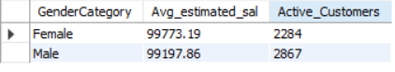
Output:

The average estimated salary is slightly higher for female customers (99,773.19) compared to male customers (99,197.86), though the difference is minimal. However, the number of active customers is higher among males (2,867) than females (2,284), indicating greater male customer participation overall.

7. Segment the customers based on their credit score and identify the segment with the highest exit rate.

Segments for customers based on their credit score.
- The customers who have a credit score over 781 as “Excellent”
- The customers with credit score between701 and 780 as “Very Good”.
- The customers with credit score between611 and 700 as “Good”
- The customers with credit score between510 and 610 as “Good” and the rest as “Poor”
After this segregation we can find number of exited customers on each credit score segment

Code:
with CreditScoreSegment as (
select CustomerId, Exited,
case when creditscore between 781 and 850 then 'Excellent'
when creditscore between 701 and 780 then 'Very Good'
when creditscore between 611 and 700 then 'Good'
when creditscore between 510 and 610 then 'Fair' else 'Poor'
end as CreditScoreSegment
from bank_churn)

select CreditScoreSegment,
avg(case when Exited = 1 then 1 else 0 end) as Exit_Rate
from creditscoresegment
group by creditscoresegment
order by exit_rate desc
limit 1;

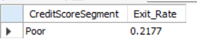
output:

Customers were categorized into five credit score segments ranging from Poor to Excellent. The exit rate for each segment was calculated by determining the proportion of customers who left the bank. The analysis shows that customers in the Poor credit score segment have the highest exit rate (21.77%), indicating that lower creditworthiness is strongly associated with higher churn behavior.

8. Find out which geographic region has the highest number of active customers with a tenure greater than 5 years.

Query:
select g.GeographyLocation,count(GeographyLocation) as active_caustomer
from customerinfo c
join bank_churn bc on c.CustomerId=bc.CustomerId
join geography g on c.GeographyID=g.GeographyID
where bc.IsActiveMember=1 and bc.Tenure>5
group by g.GeographyLocation;

Output:
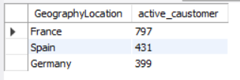

After filtering customers with tenure greater than 5 years and counting only active customers, France shows the highest number compared to Spain and Germany. This indicates stronger long-term customer retention in France among active customers.
France has the highest number of active customers with a tenure greater than 5 years, total 797 customers.

9. What is the impact of having a credit card on customer churn, based on the available data?

Customers with credit cards made up a larger percentage of those who left (1,424) than those without credit cards (613). This implies that, in terms of volume, churn is more frequent in the credit card segment.
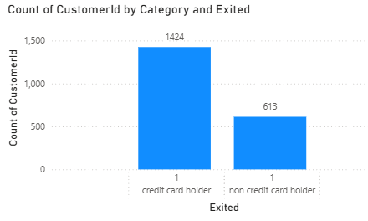

10. For customers who have exited, what is the most common number of products they have used?
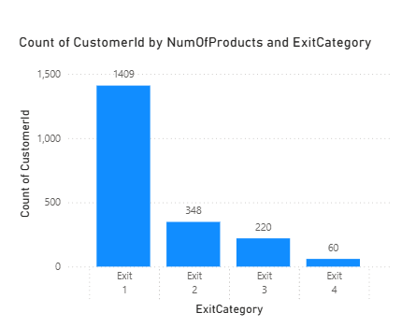
Customers who have only purchased one product account for the largest percentage of exits (1409 customers). This indicates that the group most likely to churn is single-product users. Customers with four or more products, on the various side, have the fewest exits (60), suggesting that they are less likely to leave the bank.
According to the data, customers who own just one product have the highest customer churn, whereas customers who own four products have the lowest churn. This implies that improved customer retention is linked to increased product engagement.

11. Examine the trend of customers joining over time and identify any seasonal patterns (yearly or monthly). Prepare the data through SQL and then visualize it.

Query:
YEAR(STR_TO_DATE(Bank_DOJ, '%d-%m-%Y')) AS Year,
MONTH(STR_TO_DATE(Bank_DOJ, '%d-%m-%Y')) AS Month,
COUNT(*) AS Customers_Joined
FROM customerinfo
GROUP BY
YEAR(STR_TO_DATE(Bank_DOJ, '%d-%m-%Y')),
MONTH(STR_TO_DATE(Bank_DOJ, '%d-%m-%Y'))
ORDER BY
Year, Month;

Output:
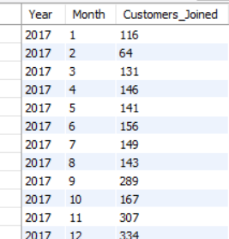
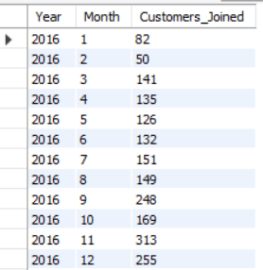

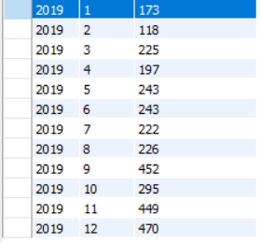
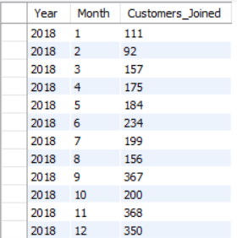

The customer joining trend appears to be increasing and decreasing frequently but overall, it is increasing.
This indicates a growth in customer acquisition.
Every year, least number of customers joined are in January and Highest number of customers join the month of July

Output in Power BI:
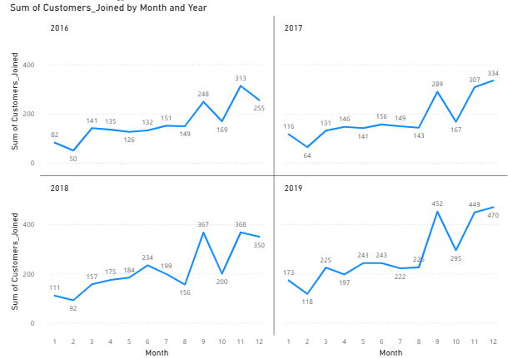

Monthly customer joins from 2016 to 2019 show a definite upward trend in growth over that period. Every year sees an increase in total customer acquisition over the year before, with 2019 exhibiting the best results and the highest monthly peaks. This consistent rise over the observed period suggests continued business growth and enhanced customer onboarding effectiveness.
Each year exhibits a consistent seasonal pattern in addition to the long-term upward trend. In broad terms, customer acquisition is lower in January and February, increases gradually in the middle of the year, and peaks in the last quarter (September and December). This consistent year-end spike over a number of years points to steady seasonal behavior, most likely caused by market or business cycles.

12. Analyze the relationship between the number of products and the account balance for customers who have exited.

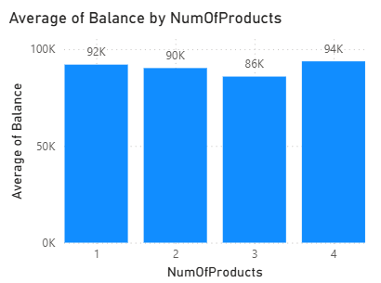

The average balance remains relatively stable across all product categories, ranging between 86K and 94K. Customers with 1 product have an average balance of approximately 92K, those with 2 products around 90K, and customers with 3 products show a slightly lower average of about 86K. customers with 4 products have the highest average balance at approximately 94K.
Overall, there is no strong linear relationship between the number of products and the average account balance among exited customers. The differences are relatively small, indicating that product count does not significantly impact the average balance at the time of exit. However, customers with four products maintain slightly higher balances compared to other groups.

13. Identify any potential outliers in terms of balance among customers who have remained with the bank.

A scatter plot can be effectively used to detect outliers by visually displaying individual data points and their distribution. In this visualization, each point represents a customer’s balance plotted against their CustomerId. Outliers appear as points that lie significantly away from the main concentration of data, making it easier to identify customers with unusually high or low balances compared to the overall pattern.
I have used below DAX, which creates a calculated column to tell which point is “normal” and which is ”outlier”.
Outlier_Flag =
VAR Q1_Value = PERCENTILEX.INC(ALL(Bank_Churn), Bank_Churn[Balance], 0.25)
VAR Q3_Value = PERCENTILEX.INC(ALL(Bank_Churn), Bank_Churn[Balance], 0.75)
VAR IQR_Value = Q3_Value - Q1_Value
VAR LowerBound = Q1_Value - (1.5 * IQR_Value)
VAR UpperBound = Q3_Value + (1.5 * IQR_Value)

RETURN
IF( Bank_Churn[Balance] < LowerBound || Bank_Churn[Balance] > UpperBound, "Outlier", "Normal" )
To systematically identify these extreme values, the Interquartile Range (IQR) method was applied. Using DAX, a calculated column named Outlier_Flag was created to classify each record as either “Normal” or “Outlier.” The formula calculates the 25th percentile (Q1) and 75th percentile (Q3) of the Balance column, determines the IQR (Q3 − Q1), and then defines lower and upper bounds using the standard 1.5 × IQR rule. Any balance falling outside this range is labeled as an outlier.
The Outlier_Flag column is then added to the scatter plot as a legend, enabling clear visual differentiation between normal data points and identified outliers
Taking , “outlier_flag” column to the scatter plot as a legend.
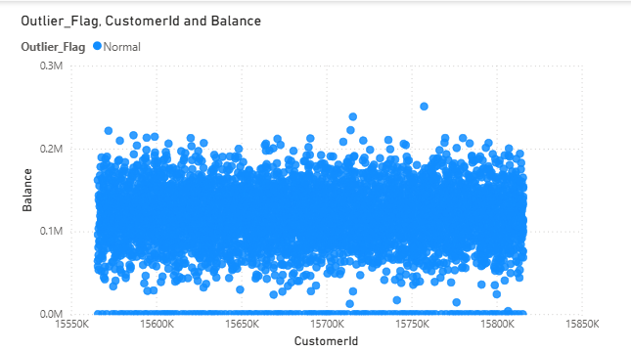
Through the plot we can analyse that , there are no outliers in the data.

14. How many different tables are given in the dataset, out of these tables which table only consists of categorical variables?

The dataset has seven different tables they are, Active Customer, Bank Churn, Credit Card, Customer Info, Exit Customer, Gender, Geography.
Categorical columns in a dataset contain discrete values that represent categories or groups rather than numerical measurements.
These columns are used for classification and grouping rather than mathematical operations.
Tables and their Categorical Variables:
- Customer Info: GeographyID, GenderIDare categorical variables.
- Bank_Churn: HasCrCard, isActiveMember and Exited are categorical variables.
- Exit Customer: ExitID and ExitCategory are categorical variables.
- Gender: GenderID and GenderCategory are categorical variables.
- Geography: GeographyID and GeographyCategory are categorical variables
- Active Customer: ActiveID and Active Category are categorical variables
- Credit Card: CreditID and CreditCategory are categorical variables.
Among the 7 tables, there are 5 tables which consists of only categorical variables. They are Exit Customer, Gender, Geography, Active Customer and Credit Card.

15. Using SQL, write a query to find out the gender-wise average income of males and females in each geography id. Also, rank the gender according to the average value. (SQL)

Query:

select geo.GeographyLocation, gn.GenderCategory,
round(avg(c.estimatedsalary),2) as Avg_salary,
rank() over (partition by GeographyLocation
order by avg(c.EstimatedSalary) desc) as 'Rank'
from customerinfo c
join geography geo on c.geographyid = geo.geographyid
join gender gn on gn.genderid=c.genderid
group by geo.geographylocation, gn.GenderCategory
order by geo.geographylocation

Output:
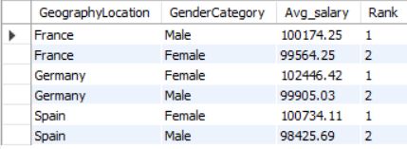

The table presents the average income by gender within each geography, along with a rank assigned based on the average salary in descending order for each location.
In France, males have a higher average income (100,174.25) compared to females (99,564.25), resulting in males receiving Rank 1 and females Rank 2.
In Germany, females earn a higher average income (102,446.42) than males (99,905.03), so females are assigned Rank 1, while males receive Rank 2.
In Spain, females again lead with an average income of 100,734.11, compared to 98,425.69 for males, placing females at Rank 1 and males at Rank 2.
Overall, the ranking is calculated independently within each geography, where the gender with the higher average income is ranked first. The results show that females have higher average incomes in Germany and Spain, while males lead in France.

16. Using SQL, write a query to find out the average tenure of the people who have exited in each age bracket (18-30, 30-50, 50+).

Query:
select
case when c.age between 18 and 30 then '18-30'
when c.age between 30 and 50 then '30-50'
else '50+'
end as age_bucket,round(avg(b.Tenure),2) as Avg_Tenure
from customerinfo c
join bank_churn b on c.CustomerId=b.CustomerId
where b.exited=1
group by case when c.age between 18 and 30 then '18-30'
when c.age between 30 and 50 then '30-50'
else '50+'
end

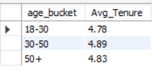
Output:

Customers aged 18–30 have an average tenure of 4.78 years, indicating that younger customers who exited stayed with the bank for nearly five years on average.
The 30–50 age group shows the highest average tenure at 4.89 years, suggesting that middle-aged customers who churned had slightly longer relationships with the bank compared to other age groups.
Customers aged 50+ have an average tenure of 4.83 years, which is marginally lower than the 30–50 group but higher than the 18–30 group. Overall, the difference in average tenure across age groups is minimal (ranging from 4.78 to 4.89 years), indicating that tenure among exited customers is relatively consistent regardless of age bracket

17. Is there any direct correlation between salary and the balance of the customers? And is it different for people who have exited or not?

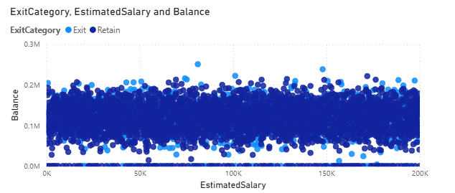

The scatter plot suggests that there is no strong or direct correlation between estimated salary and account balance. The data points are widely and evenly dispersed across the salary range from 0 to 200K, while balances remain broadly distributed without forming any upward or downward pattern. If a strong correlation existed, the points would form a clear trend line, either increasing or decreasing. Instead, the spread appears random, indicating a weak or negligible relationship between salary and balance.
When comparing customers who exited and those who retained, both categories are distributed similarly across the chart. There is no visible clustering that suggests exited customers have consistently higher or lower salaries or balances compared to retained customers. The overlap between the two groups indicates that customer churn does not appear to be directly influenced by either salary or account balance based on this visual analysis.
Overall, the plot indicates minimal to no direct correlation between salary and balance, and this relationship does not significantly differ between customers who exited and those who remained.

18. Is there any correlation between the salary and the Credit score of customers?
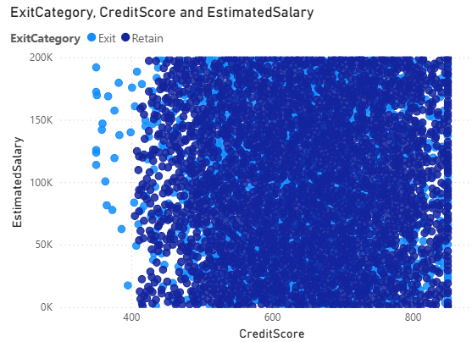

in relation to the scatter plot, the estimated salary and credit score do not show significantly or strongly correlate. There is no discernible upward or downward trend in the data points, which are widely dispersed throughout the entire range of credit scores (roughly 350–850) and salary levels (0–200K). Since there isn't a clear linear trend, it's possible that lower credit scores aren't always linked to lower income levels and higher credit scores aren't always linked to higher salaries.
Additionally, the chart shows that both retained and exited customers are evenly distributed, suggesting that there is little variation in the relationship between salary and credit score depending on churn status. In general, the visual analysis indicates that there is little to no correlation between these variables.implying that Estimated Salary and Credit Score operate independently and are not strong predictors of each other or customer exit behavior.
While some variation exists, the graph does not visually reveal any distinct pattern or correlation between these variables and exit behavior.

19. Rank each bucket of credit score as per the number of customers who have churned the bank.

DAX formulas Used:
Credit Score Bucket = IF(Bank_Churn[CreditScore]>=800,"Excellent",IF(Bank_Churn[CreditScore]>=740,"VeryGood",IF(Bank_Churn[CreditScore]>=670,"Good",IF(Bank_Churn[CreditScore]>=580,"Fair","Poor"))))
Tot_Exit_cust = CALCULATE( DISTINCTCOUNT(CustomerInfo[CustomerId]), ExitCustomer[ExitCategory]="Exit")
Cr_Score_Ranked = RANKX( all( Bank_Churn[Credit Score Bucket]), CALCULATE( DISTINCTCOUNT( CustomerInfo[CustomerId]), ExitCustomer[ExitCategory]="Exit" ) )

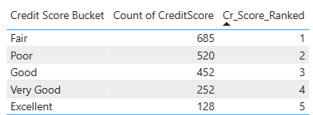
Output:

The analysis shows that customers in the Fair credit score bucket have the highest churn count, followed by those in the Poor category. As the credit score improves from Fair to Excellent, the number of churned customers steadily decreases. Customers with an Excellent credit score have the lowest churn count.
This indicates an inverse relationship between credit score quality and churn volume — higher credit score customers are less likely to exit the bank compared to lower or mid-range credit score customers.

20. According to the age buckets find the number of customers who have a credit card. Also retrieve those buckets that have lesser than average number of credit cards per bucket

Number of customers who have a credit card:
Query:
select
case when c.age between 18 and 30 then '18-30'
when c.age between 30 and 50 then '30-50'
else '50+'
end as age_bucket,count(b.HasCrCard) as count_creditcard
from customerinfo c
join bank_churn b on c.CustomerId=b.CustomerId
where b.HasCrCard=1
group by case when c.age between 18 and 30 then '18-30'
when c.age between 30 and 50 then '30-50'
else '50+'
end;

output:
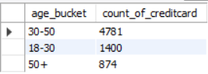

- Those buckets that have lesser than average number of credit cards per bucket
Query:
with age_buck_count as (select
case when c.age between 18 and 30 then '18-30'
when c.age between 30 and 50 then '30-50'
else '50+'
end as age_bucket,count(b.HasCrCard) as count_of_creditcard
from customerinfo c
join bank_churn b on c.CustomerId=b.CustomerId
where b.HasCrCard=1
group by case when c.age between 18 and 30 then '18-30'
when c.age between 30 and 50 then '30-50'
else '50+'
end)
select age_bucket,count_of_creditcard
from age_buck_count
where count_of_creditcard<(select avg(count_of_creditcard)
from age_buck_count)

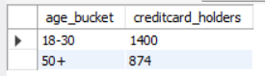
Output:

Both ‘18-30’ and ‘50 +’ age Buckets have customers more than the average of all the age buckets.
21. Rank the Locations as per the number of people who have churned the bank and average balance of the customers.
Dax formula used:
- Total customer exit:
Tot_Exit_cust=CALCULATE(DISTINCTCOUNT(CustomerInfo[CustomerId]),'ID exit'[ExitCategory]="Exit")
- Ranking:
Geog_rank=RANKX(ALL(IDgeography[GeographyLocation]), CALCULATE(DISTINCTCOUNT( CustomerInfo[CustomerId])))

Output:
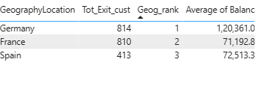
Germany ranks first in both churn count and average balance, indicating that a large number of high-value customers are exiting the bank. France ranks second in churn volume but has the lowest average balance. Spain has the lowest churn count but maintains a moderate average balance compared to France.
This shows that customer retention strategies should particularly focus on Germany, as both churn volume and financial impact are highest there

22. As we can see that the “CustomerInfo” table has the CustomerID and Surname, now if we have to join it with a table where the primary key is also a combination of CustomerID and Surname, come up with a column where the format is “CustomerID_Surname”.

We can create “CustomerID_Surname” column in Power BI by using create/add a column. Formula used:

CustomerID_Surname = CustomerInfo[CustomerId]&""&CustomerInfo[Surname]

Output can be seen in the Data view along with the table.
Output:

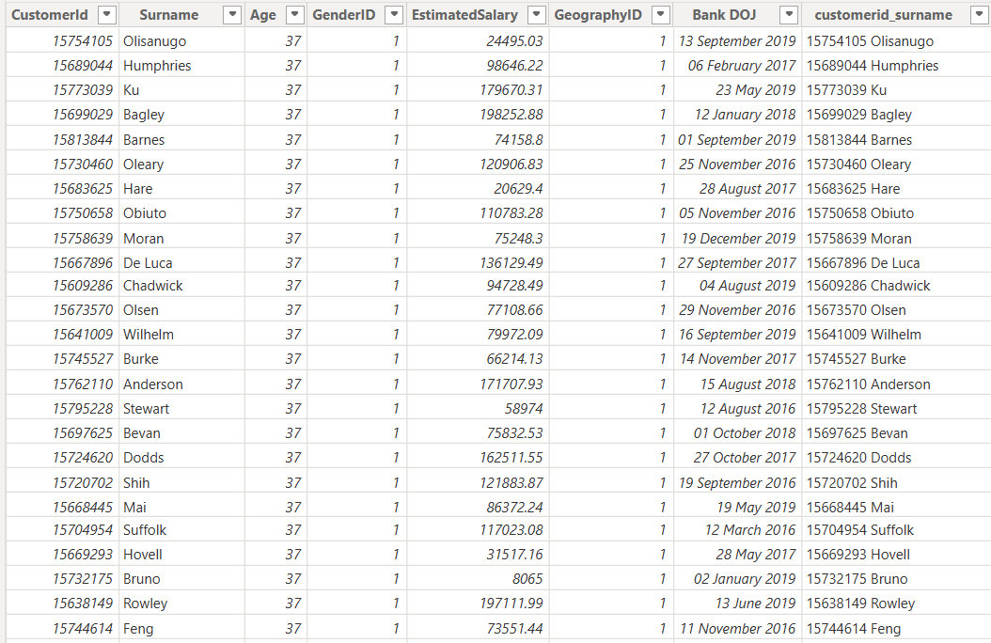

23. Without using “Join”, can we get the “ExitCategory” from ExitCustomers table to Bank_Churn table? If yes do this using SQL.

Yes, we can get Exit Category from the table ExitCustomers to bank_churn table without using any joins between them.
By using Sub-Queries this can be done based upon the common column between the tables.

Query:

select CustomerId,
Tenure,
Balance,
NumOfProducts,
HasCrCard,
IsActiveMember,
Exited,(select e.exitcategory from
exitcustomer e where e.ExitID=bc.Exited) as exitcategory
from bank_churn bc

Output:

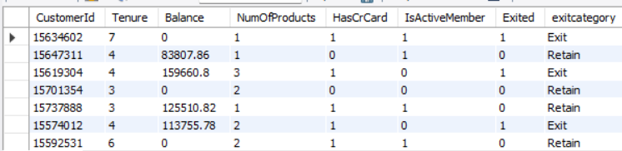

From the output we can see ExitCategory is returned form ExitCategory table and 1 in Exited column means Exit and 0 means Retain in ExitCategory.

24. Were there any missing values in the data, using which tool did you replace them and what are the ways to handle them?

There were no missing values identified in the dataset. Therefore, no imputation or data-cleaning techniques were required, and the analysis proceeded without introducing any assumptions or bias related to missing data.
However, if missing values had been present, the following standard data preprocessing techniques could have been applied:
- Deletion Method: Remove rows or columns containing missing values, particularly when the proportion of missing data is minimal and does not significantly affect the dataset’s integrity.
- Statistical Imputation: Replace missing values using statistical measures such as mean, median, or mode, or by deriving values from related variables to maintain data consistency.
- Default Value Replacement: Substitute missing entries with a predefined constant or category (e.g., 0, “Unknown,” or “Not Available”), depending on the nature of the variable and business context.

25. Write the query to get the customer IDs, their last name, and whether they are active or not for the customers whose surname ends with “on”.

Below SQL query retrieves the customer's details like customerID,Last_name and ActivityStatuts whose surname ends with “on”.

Code:
select c.CustomerId, c.Surname as Last_name,
case when b.isactivemember = 1 then 'active'
else 'inactive' end as activitystatus
from customerinfo c
join bank_churn b on c.customerid = b.customerid
where c.surname like '%on'
order by c.surname;

output:
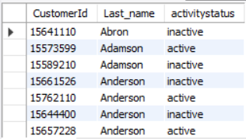

26. Can you observe any data discrepancy in the Customer’s data? As a hint it’s present in the IsActiveMember and Exited columns. One more point to consider is that the data in the Exited Column is absolutely correct and accurate.

Code:
select *
from bank_churn b
join customerinfo c on b.customerid = c.customerid
where b.exited =1 and b.isactivemember =1;
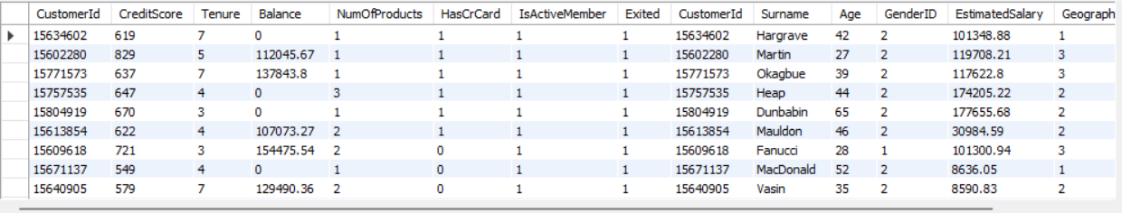
Output:
Yes, there is data discrepancy in the Customer’s data.
When the customer is Active which mean the customer is still in the bank and hence the data in IsActiveMember column is 1.
When the customer exits the bank, the Exited column is 1. But here there is data which tells us that the customer Exited and is an active member at the same time.

